Optimising recognition accuracy

Speaking style
Speak as clearly as you can, without running words together. You can speak naturally, but you will need to articulate each syllable and word a little more than you would in normal speech. Remember that Dragon is not as good at interpreting speech as a person is, so you need to give it very clear instructions.

Basic tools — use on a daily basis

Correct recognition errors
- Say “Correct that” to correct your last phrase or selected text. Alternatively say “Correct <wrong words>”

Edit the vocabulary
- “Edit vocabulary” (to find the Vocabulary Editor in Dragon Professional Individual, go to the Vocabulary menu/Open Vocabulary Editor. In Dragon Group 15 go to the Tools menu/Vocabulary Centre/open Vocabulary Editor.
- To add words and phrases to the vocabulary — dictate or type into the Search for field. Click Add
- Click I want to train the pronunciation of this word or phrase to train your pronunciation of this word or phrase, follow the prompts (this step is optional)
- Click Add
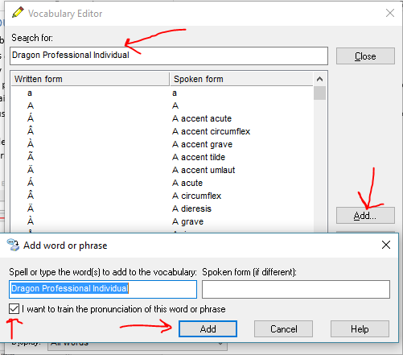
- Delete any unwanted vocabulary items if they appear in your dictation, by selecting the word or phrase/Delete
- Train your pronunciation of words that Dragon has difficulty recognising. In the Vocabulary Editor, select the word or phrase/Train/Train
- Consider using a different spoken form if appropriate — either as a shortcut or to assist with recognition accuracy
An example of a vocabulary item with a different spoken form…
Written form is 0434 877 637, spoken form is “Insert mobile number”.
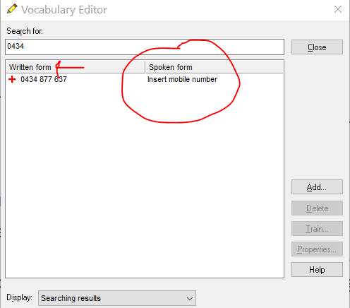

Other tools

Additional training readings (not available in Dragon 15)
- DragonBar/audio/read text to improve accuracy
- if you don’t have a lot of time to spare, avoid the readings marked ‘harder’ as these tend to be longer. Make sure you finish the reading, as Dragon won’t save anything unless you complete the reading.

Run Vocabulary Builder/scanning
This is a powerful way to optimise recognition accuracy.
During this process Dragon will scan a sample of your electronic text and add any unfamiliar words to the vocabulary. Dragon will also map the frequency and context of word usage and adapt the probability model so it is a better fit with the language you use.

First identify a Microsoft Word document which contains some sample text. Choose a document that is representative of the sort of language you generally use. It doesn’t matter whether it was written or dictated by you or by someone else.
You could direct Dragon to an existing document, or you could set up a new document and copy and paste some sample text into it. Note that Dragon can scan from a document in Word or text format, but not from other file formats including PDF.
- Go to DragonBar > Vocabulary menu> learn from specific documents (in Dragon Group 15 go to DragonBar/tools/vocabulary Centre/Learn from specific documents)
- Check Find unknown words and Adapt to writing style > Next
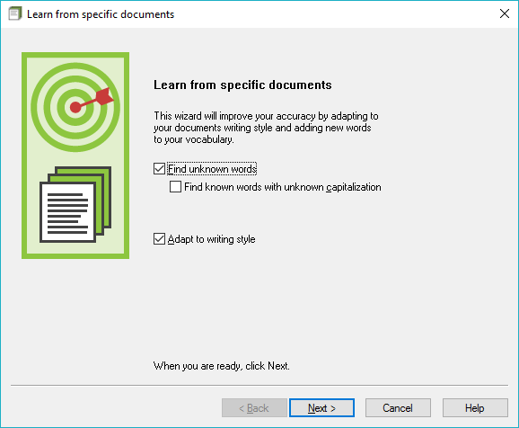
- Click Add document (or Add folder if you want to scan a whole folder of documents. I recommend scanning one document at a time so you can be more discerning about what you add to the vocabulary)
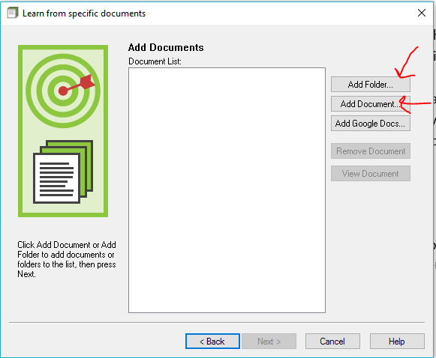
- Browse to the document you have identified and follow the prompts from here.
To check that your custom words and phrases have been added, say "Edit vocabulary", then "Display", then "Press C", to choose Custom words only from the Display drop down list.

Import a list of words and phrases
- Create a list of words and phrases, with each phrase on a new line
- save as a plain text document ie .txt
- to import the list, go to DragonBar/Vocabulary menu/import list of words or phrases (in Dragon Group 15 go to DragonBar/Tools/vocabulary Centre/import list of words or phrases).

Create custom commands/macros
- Text macros are useful for large blocks of text, as vocabulary entries are limited to 128 characters.
- Do up the text you want in Microsoft Word
- Select the text (“Press control A” to select all the text in a document) then say “Make that a shortcut”. This will bring up the MyCommands Editor, and paste the text into the content field.
- Give your command a name
- Check Plain Text if you want the text to fit in with surrounding font
- “Click Save”
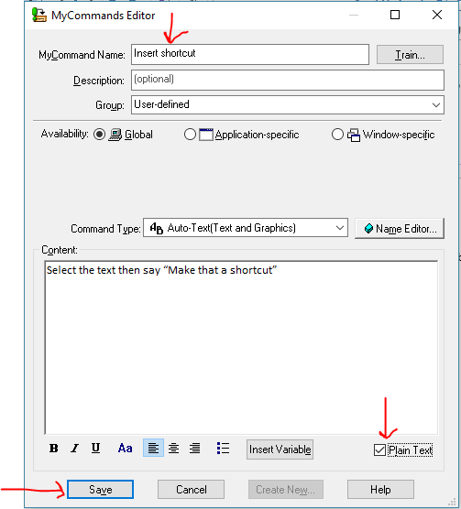

If you need to find your macro to make changes:
- say “Open Command Browser”
- say “Open Task Pane” if it is collapsed
- “Manage”
- “Global Commands”, then “Move Right” to expand the folder
- type the first couple of letters of your macro’s name, to locate your macro
- Select the macro with a single click
- “To script”
- “Edit”
- make the changes then say “Click Save”

